1. Workout: 4 x 0 x 17 =
2. Solve: (p + 2)  = 5
3. Subtract:  − ( - )
4. Fill in the missing numbers

7 7

+ 2 8

9 2

1. Three men can complete a task in a fortnight. In how many minutes can they complete the task?
2. Write : 2.5 in words.
3. Triangle ABC is on a straight line as shown in the figure below

B What is the sum of angle y and z?

y**O**

140**0** x**0**  z**0**

A C

1. Write the members of set A.

A=(boys in our class who live on the moon)

1. Find the next number in the sequence

1, 3, 9, 27, 81, ______

1. Solve: x + (3x – 2) = 18
2. A trapezoidal backyard has an area of 100m**2**. The front and back width

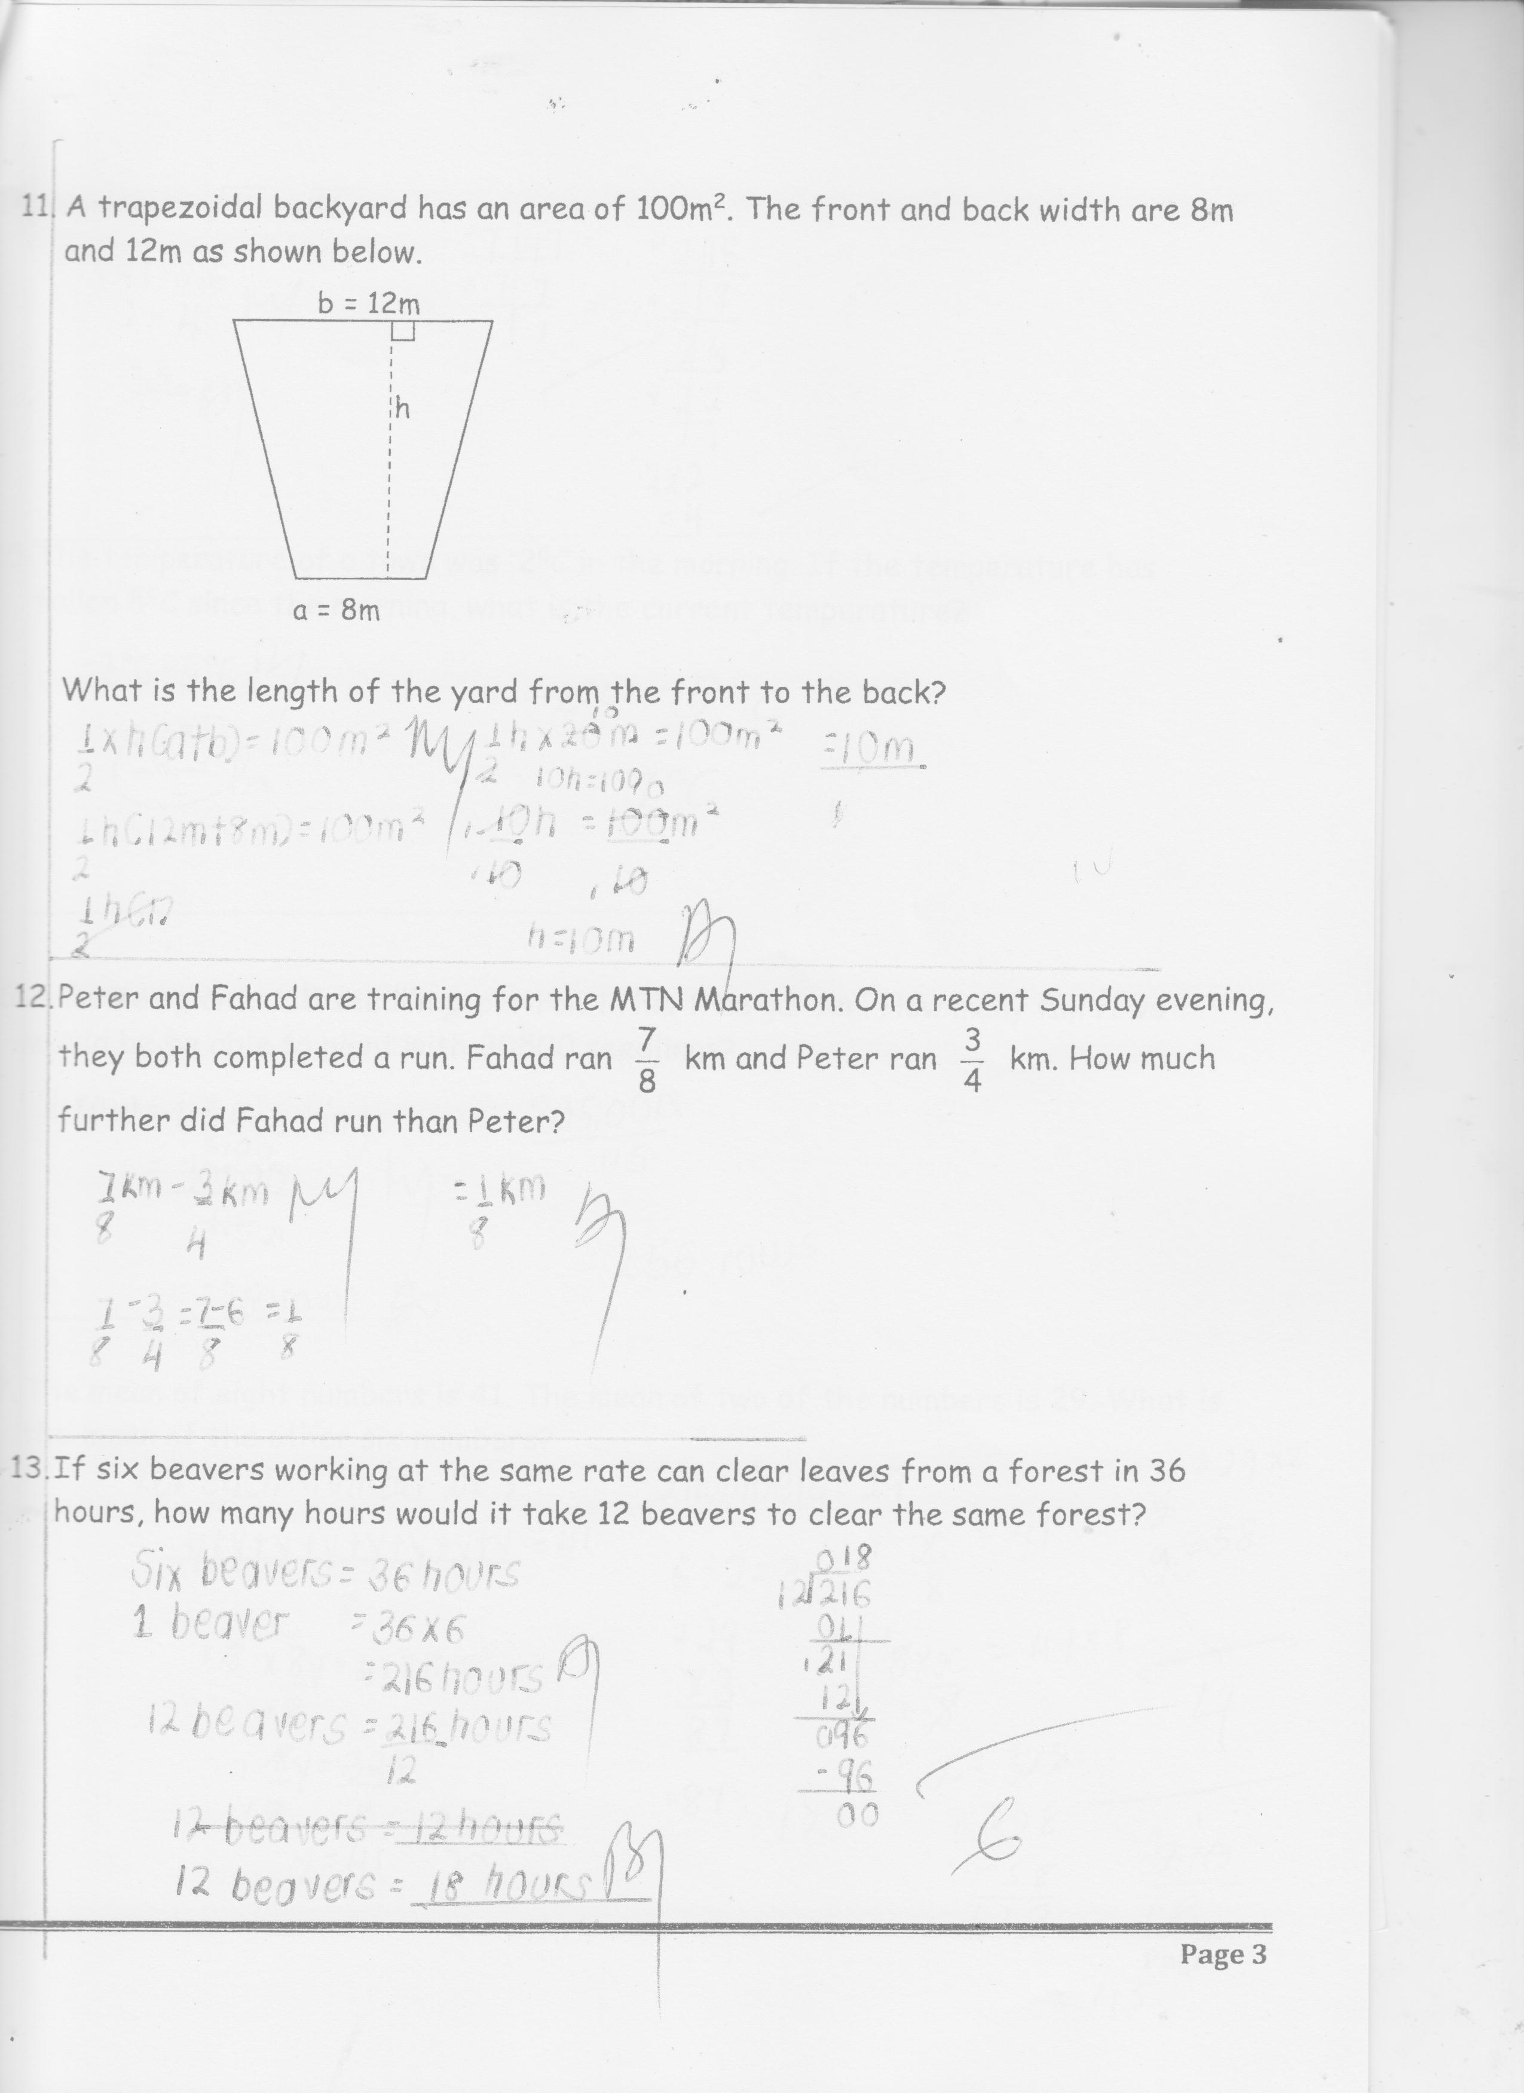 are 8m and 12m as shown below

1. Peter and Fahad are training for the MTN Marathon. On a recent Sunday evening, they both completed a run. Fahad ran km and Peter ran km. How much further did Fahad run than Peter?

1. If six beavers working at the same rate can clear leaves from a forest in

36 hours, how many hours would it take 12 beavers to clear the same

forest?

1. Work out: 49 - 16
2. The temperature of a town was -2**0**C in the morning. If the temperature

has fallen 5**0**C since the morning, What is the current temperature?

1. A farmer plants 115 seedlings per row in his tree garden. How many full

rows would he be able to plant with 30500 seedlings?

1. The mean of eight numbers is 41. The mean of two of the numbers is 29.

What is the mean of the other six numbers?

1. Find the reciprocal of;



1. Regina reads two books each week. Rhoda reads one book every two

months. How many more books does Regina read than Rhoda in a year?

1. If petrol costs shs. 3800 per litre and your car has a 16 – litre tank that is

 empty. How much will it cost to fill the tank?

**SECTION B (60 MARKS)**

1. Use the number line below to answer the questions that follow

** P**

**R**

1. Find the value of arrows P and R
2. P ___________________________

1. R ___________________________
2. Evaluate : **-**2 – (**-**4) - 2
3. In a school, there are a total of 5760 boys and girls. If there are 358

more girls than boys, how many boys are there in the school?

1. A farmer plants a variety of crops on his land,  of the land with maize,  with soya beans,  with wheat and the rest with sweet potatoes.

a) Which fraction was planted with sweet potatoes? (2marks)

b) Which crop takes up the least land? (3marks)

1. a) Study the price list below and answer the questions that follow

|  |  |
| --- | --- |
| Guava | 3 for 1 US dollar |
| Orange | 5 for 1 US dollar |
| Mango | 2 for 1 US dollar |

What is the total cost of 5 oranges, 9 guavas and 4 mangoes in Ug. shillings if the exchange rate is 1 US dollar= 3654Ug. shillings?

1. A rectangular garden has been fenced using wire and poles. There are 5 metres between poles. Find the perimeter of the garden if there are 18 poles used to enclose the garden.

1. Of the cards in a box,  are red, 60 are blue and the remaining 40% are yellow. How many cards are in the box?

1. a)Round off 9.5467 to the nearest hundredths.

b) Simplify:  without using fractions

1. a) Using a pair of compasses, a ruler and a pencil only, construct a triangle ABC in which angle CAB = 105**0**, line AB = 7cm and angle ABC = 30**0**.

b) Measure the length of BC.

1. In a class, 25 pupils like Maths (M), 2r like Science (S) only, r like both subjects while 7 pupils like other subjects.
2. Use the information above to complete.

M = S =

_____ r _____

7

1. If n (MS) = 45, find the value of r.

1. Find the total number of pupils in the class.

1. A regular polygon has a side measuring 4.5cm and its exterior angle is 450.
2. Workout the perimeter of the polygon.
3. How many right angles are in the polygon?
4. Use 1023 to answer the questions that follow
5. Find the product of the value of 1 and 2
6. Show the number above on the abacus below

1. The graph below shows the number of students who attended school

on the five days of a week out of 800 students in Kakoge P/S

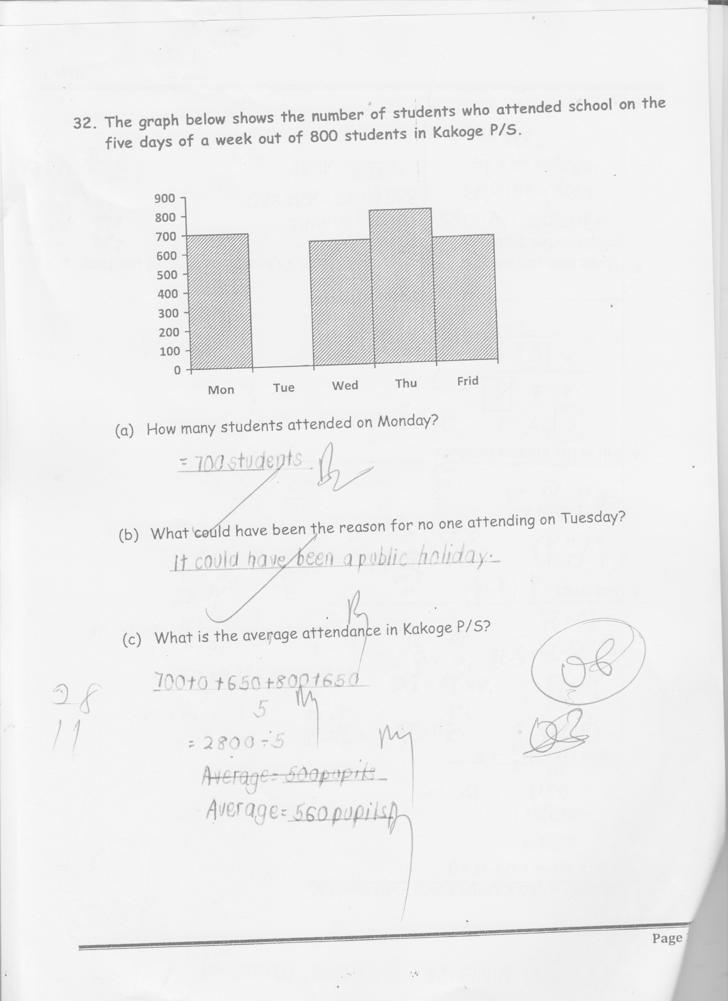

1. How many students attended on Monday?
2. What could have been the reason for no one attending on Tuesday?
3. What is the average attendance in Kakoge P/S?

**END**